Sohal Patel

Week 2

Use the contents of Figure 2.1 to work Problems 1–3.

1. Given the information in the two tables, you can see that an AGENT – through AGENT_CODE can happen commonly in the CUSTOMER table. Be that as it may, every customer has just one agent. In this manner, the business rule might be composed as pursues:

* One agent can have numerous customers.
* Every customer has just a single agent.



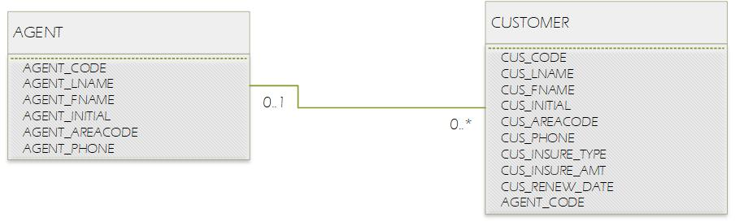

1. Each store is situated in just a single region. Hence, the connection among REGION and STORE is 1:M. The store employs many employees. Every employee is employed by one store. For this situation, we are assuming that the business principle determines that an employee can't work in more than one store at once. Along these lines, the connection among STORE and EMPLOYEE is 1:M. A job –, for example, bookkeeper can be assigned out too many employees. (For example, one would sensibly assume that a store can have more than one bookkeeper. Accordingly, the job title "accountant" can be allocated to more than one employee at once.) Every employee can have just one job assignment. (For this situation, we are assuming that the business standard indicates that an employee can't have more than one job assignment at once.) Accordingly, the connection among JOB and EMPLOYEE is 1:M.
2. The relationships are 1:M and we can write the business rules as:

* COURSE creates CLASS. One course can produce numerous classes. Each class is produced by one course.
* CLASS is referenced in ENROLL. One class can be referenced in enrollment commonly. Each singular enrollment references one class. Note that the ENROLL element is likewise identified with STUDENT. Every section in the ENROLL substance references one student and the class for which that student has enrolled. A student can't enroll in a similar class more than once. On the off chance that a student enrolls in six classes, that student will show up in the ENROLL substance multiple times, each time for an alternate class.
* STUDENT is appeared in ENROLL. One student can be appeared in enrollment ordinarily. In database configuration terms, "many" basically signifies "more than once." Every individual enrollment section demonstrates one student.

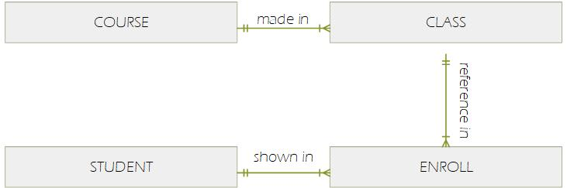

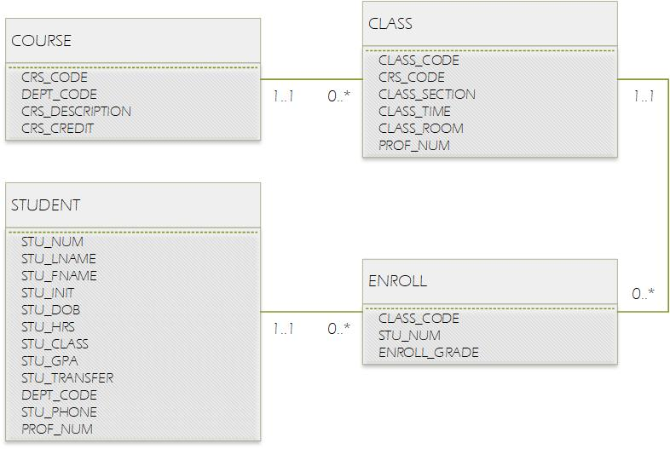8.